Exp 1
Aim : Implement stack and Queue using array

Theory:

Stack:
In computer science, a stack is an abstract data type and data structure based on the principle of Last In First Out (LIFO).
A stack is an ordered list of items.
Items are removed from this list in the reverse order to the order of their addition.
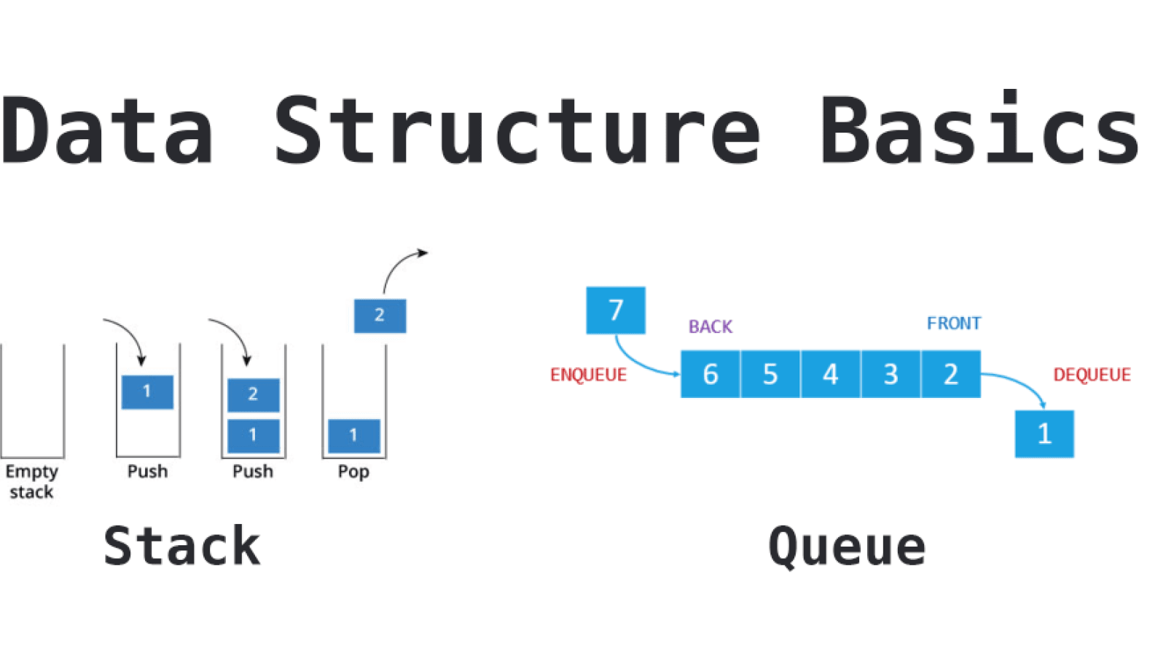
There are two main operations: push and pop. The push operation adds (stores) to the list. Due to practical memory limits, stacks are often of a particular size, so this operation must check that the stack is not full, otherwise it will fail. The pop operation removes (deletes) an item from the list, AND returns or exports this item value to the calling program. The pop operation must check to see if the stack is not empty, otherwise it will fail.
A stack's data structure can be implemented by other data structures such as arrays, linked lists.
Stack can be implemented by using array as follows:-
Int Stack[size];
Int top=-1;

Void push() Void pop()
{ {
If( top== size-1) if(top==-1)
Printf(“Stack overflow”); Printf(“Stack underflow”);
Else else
Printf(“Enter the element”) printf(“Element poped is %d”,Stack[top--]);
Scanf(“%d”,&ele); }
Stack[++top]=ele;
}

Queue:
In computer science, a queue is an abstract data type and data structure based on the principle of First In First Out(LIFO).
A queue is an ordered list of items.
Items are removed from this list in the same order to the order of their addition.
There are two main operations: insert and delete. The insert operation adds (stores) to the list. Due to practical memory limits, queues are often of a particular size, so this operation must check that the queue is not full, otherwise it will fail. The delete operation removes an item from the list, and returns or exports this item value to the calling program. The pop operation must check to see if the queue is not empty, otherwise it will fail. In queue elements and added form rear end and deleted from front end
A queue data structure can be implemented by other data structures such as arrays, linked lists.
Queue can be implemented by using array as follows:-
Int Queue[size];
Int rear=-1,front=0;

Void insert() Void delete()
{ {
If( rear== size-1) if(rear<font)
Printf(“Queue overflow”); Printf(“Queue underflow”);
Else else
Printf(“Enter the element”) printf(“Element deleted is %d”,Queue[front++]);
Scanf(“%d”,&ele); }
Queue[++rear]=ele;
}

conclusion : Thus we have implemented Stack and queue using array.

Exp 2
Aim : Implementation of Evaluation of expressions
Theory:
A postfix expression is a collection of operators and operands in which the operator is placed after the operands.
Ex: the infix expression 2+3*4 is 234*+ in postfix notation and 2 3 1 * + 9 - is postfix of 2+ 3 *1 - 9
The Postfix notation is used to represent algebraic expressions.
The expressions written in postfix form are evaluated faster compared to infix notation as parenthesis are not required in postfix.
Evaluation of postfix Expression:
A postfix expression can be evaluated using the Stack data structure. To evaluate a postfix expression using Stack data structure we can use the following steps...
1. Read all the symbols one by one from left to right in the given Postfix Expression
2. If the reading symbol is operand, then push it on to the Stack.
3. If the reading symbol is operator (+ , - , * , / etc.,), then perform TWO pop operations and store the two popped oparands in two different variables (operand1 and operand2). Then perform reading symbol operation using operand1 and operand2 and push result back on to the Stack.
Finally! perform a pop operation and display the popped value as final result.
Eg:

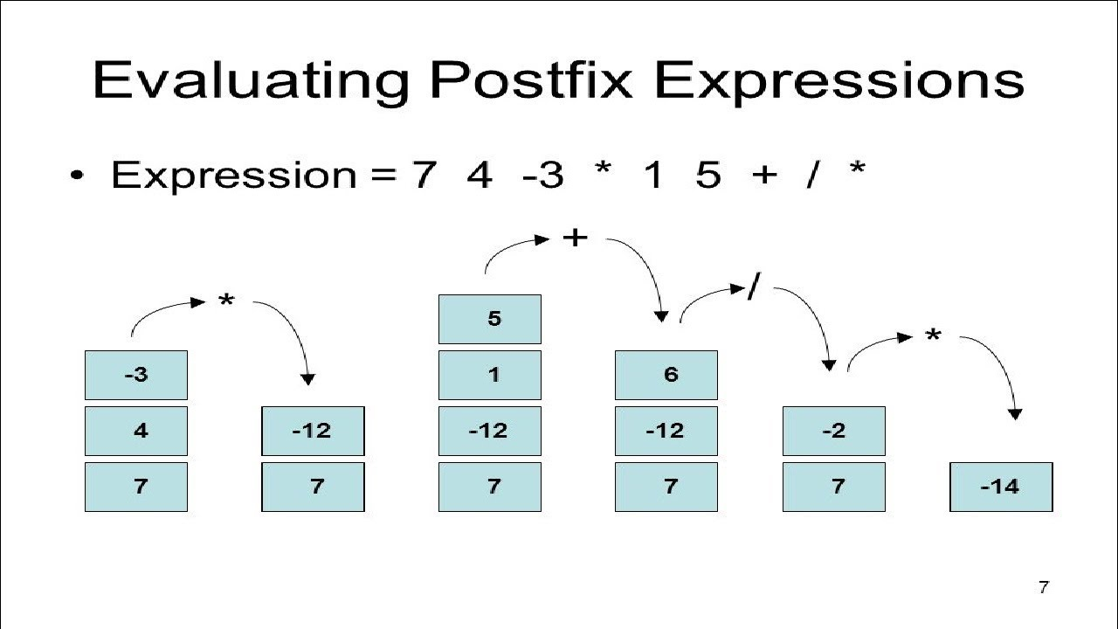

Conclusion : Thus we have implemented Evaluation of expressions
Exp 3

Aim : Program to implement single and doubly Linked list

Theory :
Single Linked List:
In computer science, a linked list is a data structure that consists of a sequence of data records such that in each record there is a field that contains a reference (i.e., a link) to the next record in the sequence.

Linked lists are among the simplest and most common data structures, and are used to implement many important abstract data structures, such as stacks, queues, hash tables, symbolic expressions, skip lists, and many more.
The principal benefit of a linked list over a conventional array is that the order of the linked items may be different from the order that the data items are stored in memory or on disk. For that reason, linked lists allow insertion and removal of nodes at any point in the list, with a constant number of operations.
On the other hand, linked lists by themselves do not allow random access to the data, or any form of efficient indexing. Thus, many basic operations — such as obtaining the last node of the list, or finding a node that contains a given data, or locating the place where a new node should be inserted — may require scanning most of the list elements.

Linked list operations
Our node data structure will have two fields. We also keep a variable firstNode which always points to the first node in the list, or is null for an empty list

record Node {
data // The data being stored in the node
next // A reference to the next node, null for last node
}

Node firstNode

1. Traversal of a singly-linked list
node := list.firstNode
while node not null {
(do something with node.data)
node := node.next
}

2. Inserting a node after an existing node in a singly linked list

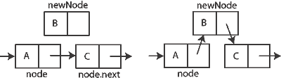

3. Removing the node after a given node

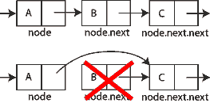

Doubly Linked List:
In computer science, a doubly-linked list is a linked data structure that consists of a set of data records, each having two special link fields that contain references to the previous and to the next record in the sequence. It can be viewed as two singly-linked lists formed from the same data items, in two opposite orders.

A doubly-linked list whose nodes contain three fields: an integer value, the link to the next node, and the link to the previous node.
The two links allow walking along the list in either direction with equal ease. Compared to a singly-linked list, modifying a doubly-linked list usually requires changing more pointers, but is sometimes simpler because there is no need to keep track of the address of the previous node.
.
Linked list operations
Our node data structure will have three fields. We also keep a variable firstNode which always points to the first node in the list, or is null for an empty list

record Node {
data // The data being stored in the node
next // A reference to the next node; null for last node
prev // A reference to the previous node; null for first node
}
Node firstNode

1. Traversal of a doubly-linked list
node := list.firstNode
while node not null {
(do something with node.data)
node := node.next
}

2. Inserting a node after an existing node in a doubly linked list

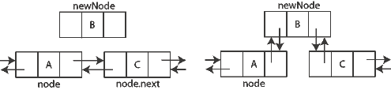

3. Removing the node after a given node

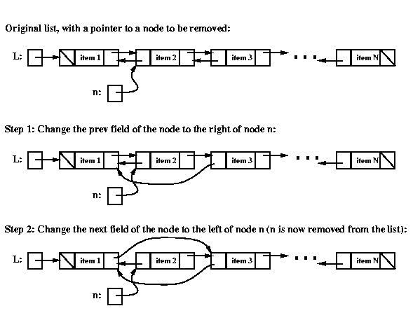

Conclusion: Thus we have ipmlemented single and Doubly linked list

Exp: 4
Aim: Implementation of Satck and queue using linked list

Theory :
we can also use linked list to implement stack. Linked list allocates the memory dynamically. However, time complexity in both the scenario is same for all the operations i.e. push, pop and peek.

In linked list implementation of stack, the nodes are maintained non-contiguously in the memory. Each node contains a pointer to its immediate successor node in the stack. Stack is said to be overflown if the space left in the memory heap is not enough to create a node.

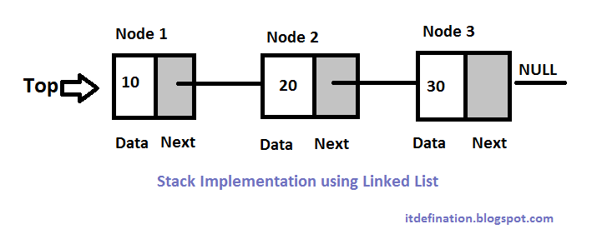

The array implementation can not be used for the large scale applications where the queues are implemented. One of the alternative of array implementation is linked list implementation of queue.

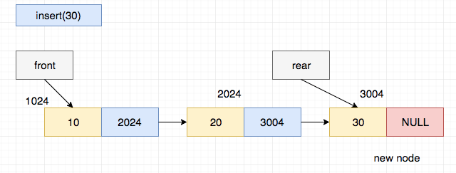

conclusion : Thus we have implemented Stack and queue using linked list

Exp: 5
Aim: Implementation of Binary tree traversals
Theory:
Binary Tree:
In computer science, a binary tree is a tree data structure in which each node has at most two children. Typically the first node is known as the parent and the child nodes are called left and right.

Def: A Binary tree is a finite set of elements that is either empty or is partitioned into three disjoint subset. First contain single element called root. The other subsets are themselves binary trees called as left and right sub trees or it can be empty.

Types of binary trees:
- Strictly Binary tree: If every non leaf node in a binary tree has nonempty left and right sub trees then this binary tree is called as strictly binary tree.
- Complete Binary tree: A complete binary tree of depth d is strictly binary tree of depth d all of whose leaves are at level d.
- Skewed tree: If every node is having only left and right sub tree Then it is called as left or right skewed tree.
- Almost Complete binary tree: A binary tree of depth d is an almost complete binary tree if
  - Any node nd at level less than d-1 has two sons
  - For any node nd in the tree with a right descendent at level d ,nd must have a left son and every left descendent of nd is either a leaf at level d or has two sons.
Tree traversal:
In computer science, tree-traversal refers to the process of visiting (examining and/or updating) each node in a tree data structure, exactly once, in a systematic way. Such traversals are classified by the order in which the nodes are visited. Tree structures can be traversed in many different ways. Starting at the root of a binary tree, there are three main steps that can be performed and the order in which they are performed defines the traversal type.
To traverse a non-empty binary tree in preorder, perform the following operations recursively at each node, starting with the root node:
- Visit the node.
- Traverse the left sub tree.
- Traverse the right subtree.
(This is also called Depth-first traversal.)
To traverse a non-empty binary tree in inorder, perform the following operations recursively at each node:
- Traverse the left subtree.
- Visit the node.
- Traverse the right subtree.
(This is also called Symmetric traversal.)
To traverse a non-empty binary tree in postorder, perform the following operations recursively at each node:
- Traverse the left subtree.
- Traverse the right subtree.
- Visit the node.

Example
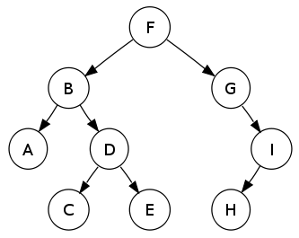
In this binary search tree,
- Preorder traversal sequence: F, B, A, D, C, E, G, I, H (root, left, right)
- Inorder traversal sequence: A, B, C, D, E, F, G, H, I (left, root, right)
- Postorder traversal sequence: A, C, E, D, B, H, I, G, F (left, right, root

Conclusion: thus we have Implemented of Binary tree traversals

